

*nRF 5 – Software cheatsheet*

Table des matières

nRF 5 – Software cheatsheet 0

1. nRF Software 2

1.1. Toolchain installation 2

Toolchains 5

nRF52840 6

Devlopment Kit 7

1.2. Modifying a sample application 7

Adding files 7

2. Android Application for smartphone 7

2.1. Requirements specification 7

2.2. Software – IDE 8

3. Software update of the Embedded System 9

Software 9

# nRF Software

## Software architecture

https://www.nordicsemi.com/Software-and-tools/Software/Bluetooth-Software

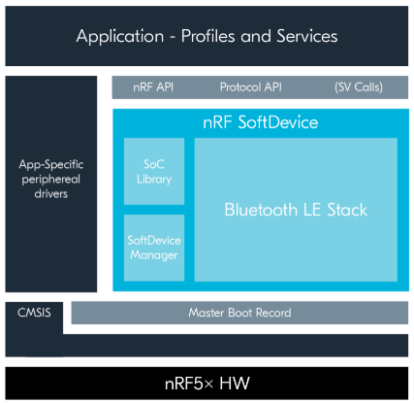

## Toolchain installation

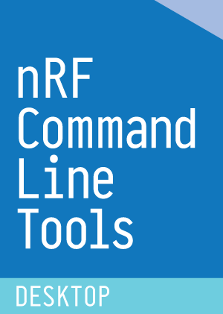

4 – nRF CLI – V10.8.0

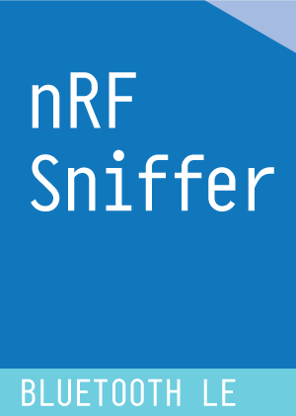



1 - nRF Connect SDK -V1.3.0

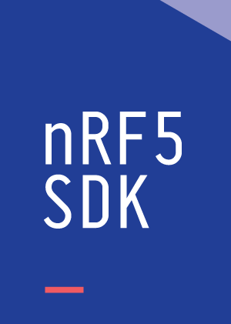

2 - nRF5 SDK V15.3



3 – nRF Connect for Desktop

* nRF5 SDK: Software development kit for the nRF52 Series and nRF51 Series SoCs
* nRF Connct SDK: provides libraries and example applications
* nRF Connect :Testing app, PC tool for testing/debugging connections: do application independent operations, (central or peripheral roles) can send some some datas over UART/ble.

Cross-platform development software for Bluetooth Low Energy and cIoT, nRF Connect will automatically detect which kit is connected to your computer and upload the needed firmware. Need a second nRF DK or Dongue to emit the Bluetooth test signal

* Bluetooth Low Energy: General tool for development and testing with Bluetooth Low Energy
* Toolchain manager: Install and manage tools to develop with the nRF Connect SDK (NCS)

SDK installation use the .exe file on the SEGGER web site

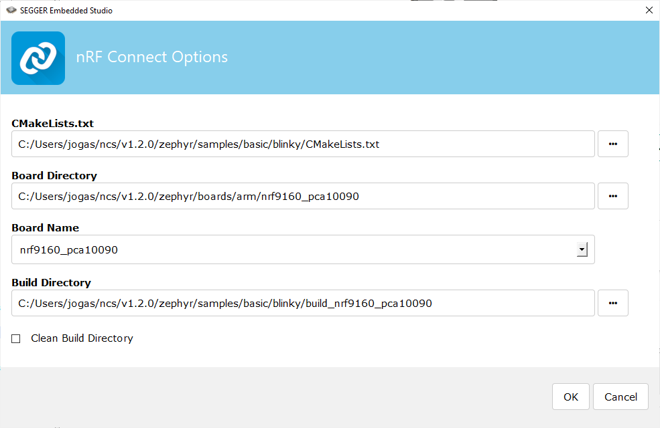

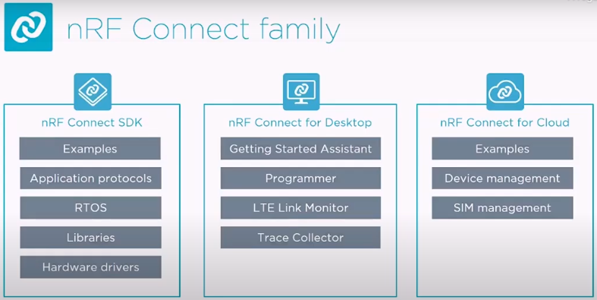

* Getting Started Assistant: Guide to set up the nRF Connect SDK
* nRF Sniffer for Bluetooth LE: useful tool for debugging and learning about Bluetooth Low Energy applications. To use the nRF Sniffer for Bluetooth LE you need either the nRF52840 DK, nRF52 DK, nRF51 DK or the nRF51 Dongle.
* Softdevice S112: Memory-optimized Peripheral-only Bluetooth Low Energy protocol stack
* Zephyr™ Real-time operating system (RTOS) , which is built for connected low power product
* West: swiss-army knife command line tool for Zephyr, West’s built-in commands provide a multiple repository management like Git. Zephyr uses this feature to provide conveniences for building applications, flashing and debugging them, and more.

Installation:

* Getting started & Installing the SDK:: <https://infocenter.nordicsemi.com/index.jsp?topic=%2Fug_getting_started%2FUG%2Fcommon%2Fnordic_tools.html&cp=1_0_1>

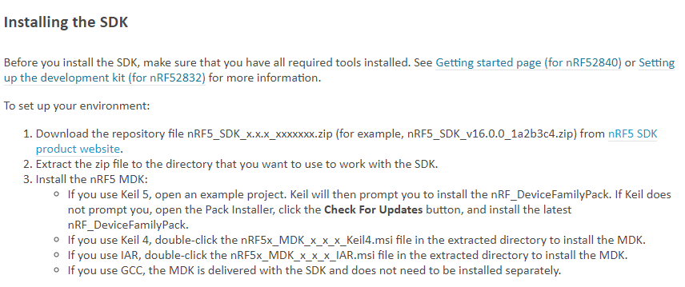

* Getting started : <https://infocenter.nordicsemi.com/index.jsp?topic=%2Fug_getting_started%2FUG%2Fgs%2Fdevelop_sw.html&cp=1_0_2>
* Building with SES (segger): <https://developer.nordicsemi.com/nRF_Connect_SDK/doc/latest/nrf/gs_programming.html>
* Sample and application: <http://developer.nordicsemi.com/nRF_Connect_SDK/doc/latest/nrf/examples.html>

Develop with Bluetooth: <https://www.bluetooth.com/develop-with-bluetooth/>

Drag and drop un fichier HEX sur le périphérique usb J-LINK pour le flash dans le MCU.

* IDE: Integrated Development Environment
* SDK: Software Development Kits (SDKs) are your starting point for software development on the nRF51 and nRF52 Series. They contain source code libraries and example applications covering wireless functions, libraries for all peripherals, bootloaders, Wired and OTA firmware upgrades, RTOS examples, serialization libraries and more. Some of the specialized SDKs are installed on top of the generic nRF5 SDK and extend its functionality.
* Nordic Semiconductor provides Software Development Kits to facilitate firmware development for different devices and applications. The SDKs contain examples that are tailored to run on Nordic Semiconductor's Development Kits.
* MDK Microcontroller Development Kit
* GNU: **G**NU’s **N**ot **U**NIX, operating system
* <https://infocenter.nordicsemi.com/index.jsp?topic=%2Fug_getting_started%2FUG%2Fgs%2Fdevelop_sw.html&cp=1_0_2>

CMAKE & GCC

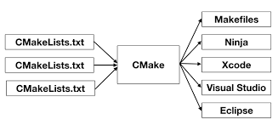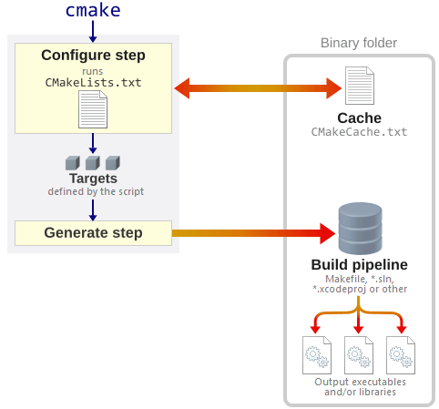

<https://stackoverflow.com/questions/39761924/understanding-roles-of-cmake-make-and-gcc>

### Toolchains

Supported IDE by the nRF5 SDK

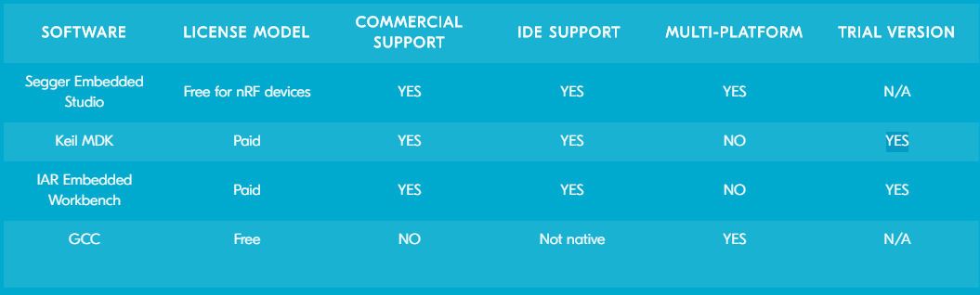

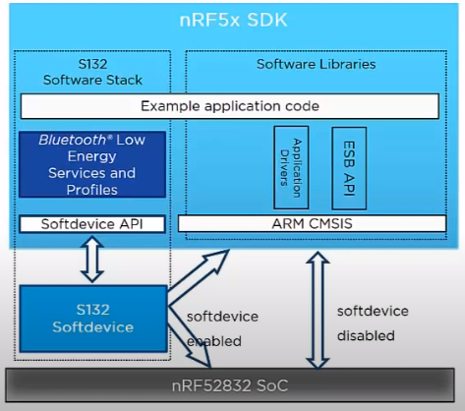

5 - SDK Introduction video

ARM CMSIS: Cortex Microcontroller Software Interface Standard, hardware abstraction layer.

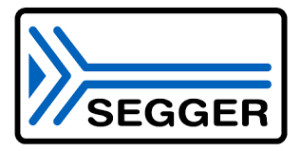

6 – IDE - Software Development tools for embedded Systems

### nRF52840

nRF52840 SoC: System on Chips = uController

Bluetooth 5, Bluetooth mesh

MCU: microcontroller unit

SPI

API: application programming interface

<https://infocenter.nordicsemi.com/index.jsp?topic=%2Fug_getting_started%2FUG%2Fgs%2Fdevelop_sw.html&cp=1_0_2>

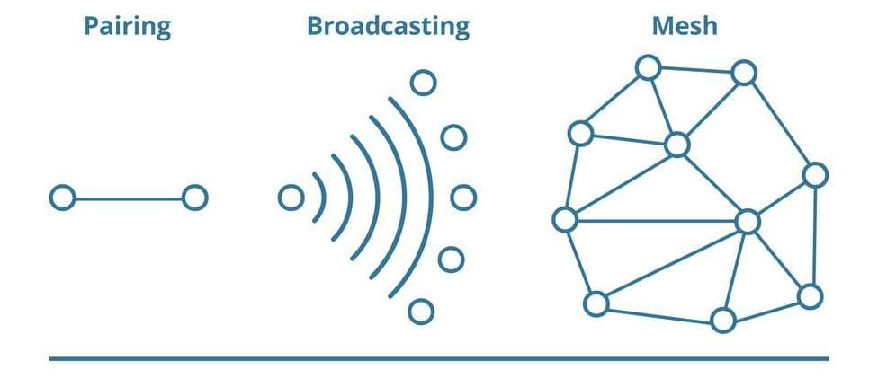

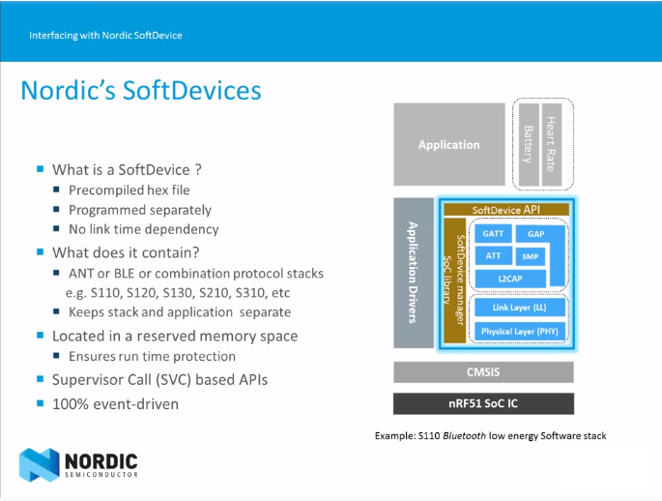

<https://www.youtube.com/watch?v=tZjlixQPO-Q>

### Devlopment Kit

* Supports Bluetooth LE
* User-programmable LEDs(4) and buttons(4)
* BLE, ANT, 2.4 GHz
* SWF RF connector for direct RF measurements 🡪 sniffer
* On-board SEGGER J-Link debugger/programme
* Pins for measuring power consumption
* 1.7-5.0 V supply from USB, external, Li-Po battery or CR2032 coin cell battery
* (Arduino shild compatible 🡪 amelioration, cheap hardware)

## Modifying a sample application

<https://developer.nordicsemi.com/nRF_Connect_SDK/doc/latest/nrf/gs_modifying.html>

### Open a project

Search the file: softdevice/ses/xxx_pca10056.emProject

* F7: Build the project -> create the zypher.elf file
* F5: Debug/Go

### Adding files

* Modify *CMakeList.txt* directly with Segger
* Use tags:

*# NORDIC SDK APP START*

target_sources(app PRIVATE src/main.c)

*# NORDIC SDK APP END*

### Softdevice

Library for Bluetooth and ANT, located in folder components\softdevice\SoftDevice\hex (precompiled)

## Configuring your application in Debug

<https://infocenter.nordicsemi.com/index.jsp?topic=%2Fug_getting_started%2FUG%2Fgs%2Fdevelop_sw.html&cp=1_0_2>

set CONFIG_DEBUG_OPTIMIZATIONS to y

Default configuration for:

* A Library: Kconfig (& prj.conf permanently changes)
* A Board: *_defconfig & Kconfig.defconfig

(Write your devicetree n the Zephyr documentation for more information)

<https://developer.nordicsemi.com/nRF_Connect_SDK/doc/latest/zephyr/application/index.html#application-kconfig>

# Android Application for smartphone

## Requirements specification

* Smartphone android (Model : …)

1. Concevoir, implémenter et tester une simple application Android permettant l'accès au BMS.

The application should inform about:

* Battery level
* Number of charges
* Problems occurred
  + health record of the battery
* BMS serial number
* (Bike serial Number)
* (Power/Torque of the motor)

## Software – IDE

7 - nRF Connect for Mobile



3 - Android Studio

Application IDE

(With Bluetooth low-level java library)

# Software update of the Embedded System

Solution 1: Bluetooth Module connected to pin …., …. To flash/reprogram the uC Pic of the BMS

Solutions 2: Tirer du wrapfile

PIC 5V, ARM 3V3 🡪 use voltage stepper, with the development board

Patrice Rudaz est spécifié dans cette tâche.

Modifier la schématique Altium une fois le module validé

### Software

nRF Util is a development tool for generating DFU packages

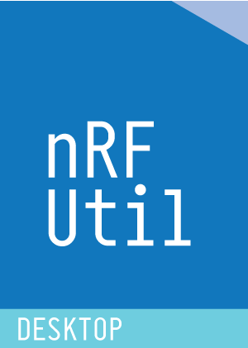Device firmware update (DFU) package generation

Cryptographic key generation, management, and storage

Bootloader settings generation

DFU procedure over the following transports

* Bluetooth Low Energy
* Serial over UART
* Serial over USB
* Thread unicast
* Thread multicast
* Zigbee
* ANT

Pas de SPI

<https://github.com/NordicSemiconductor/Android-BLE-Library/>